Project Development Phase
Model Performance Test

Date | 10 February 2025
Team ID | PNT2022TMIDxxxxx
Project Name | Import Data using Transform Maps (Spreadsheet)
Maximum Marks

Model Performance Testing:
Project team shall fill the following information in model performance testing template.
S.No. | Parameter | Values | Screenshot
 | Model Summary | Model Summary: No AI model is used. Automation setup in ServiceNow: spreadsheet (5 student records) → import set table u_student_import → Transform Map "Student Information" → table u_student_information. | 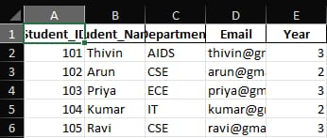
 | Accuracy | Training Accuracy – Not applicable  Validation Accuracy – Not applicable  Import accuracy: 5 of 5 records inserted, 0 errors (100%).
3. | Fine Tunning Result( if Done) | Fine tuning: Not done / not applicable.  Validation Accuracy – Not applicable (no model). Data verified through the report on the Student Information table. | 